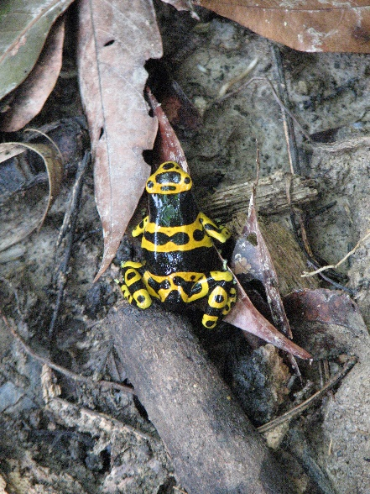

Image Caption: Bumblebee poison dart frog (*Dendrobates leucomelas*)

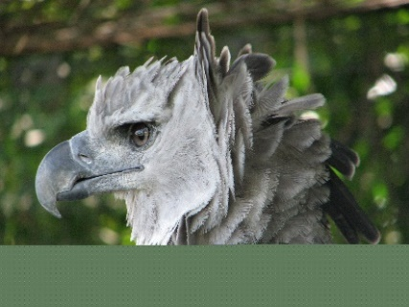

Image Caption: Harpy eagle (*Harpia harpyja*)

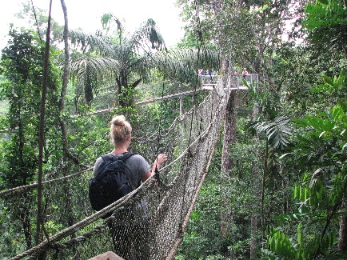

Image Caption: Canopy Walkway - Iwokrama

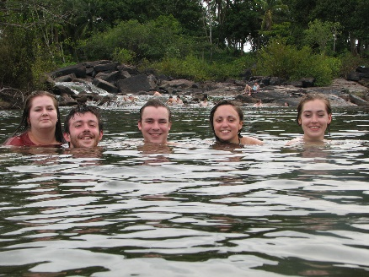

Image Caption: Swimming in the Essequibo River

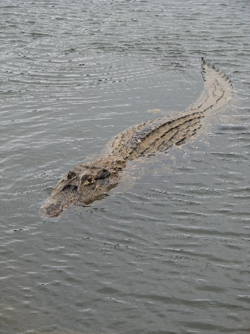

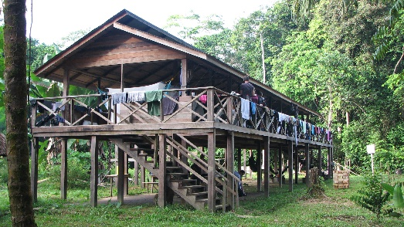Image Caption: Black caiman (*Melanosuchus niger*)

Image Caption: River Lodge - Surama

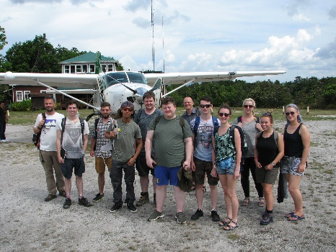

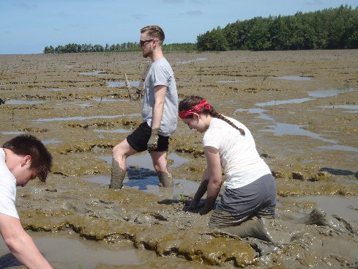Image Caption: Group after internal flight to Kaieteur

Image Caption: Mangrove planting

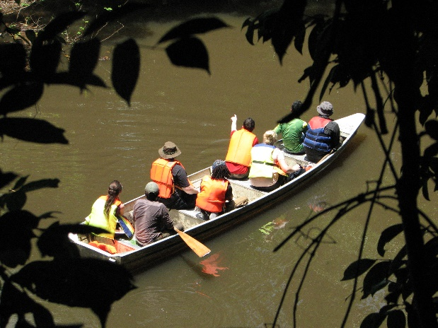

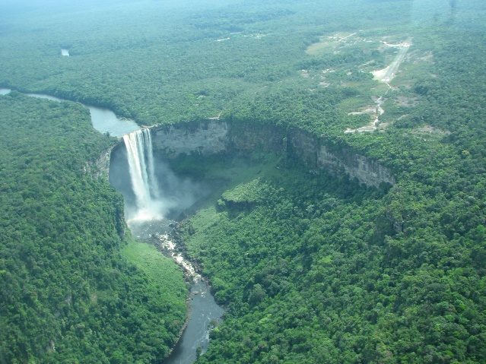Image Caption: Spotting wildlife on the Burro Burro river

Image Caption: Kaieteur Falls